1. 
2. 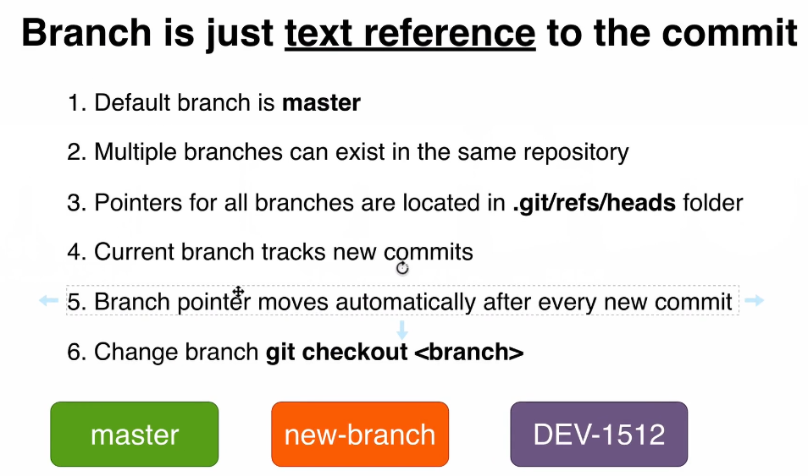
3. **Dev-1512**:
   1. Branch name example commonly used in large company.
   2. 1512: # of a ticket assigned to a specific developer.
   3. **Dev**:
      1. Short version of Project name.
      2. or Micro-Service Name that is developed by a group of people.
4. **Valid Branch Name**:
   1. No space in branch name.
   2. 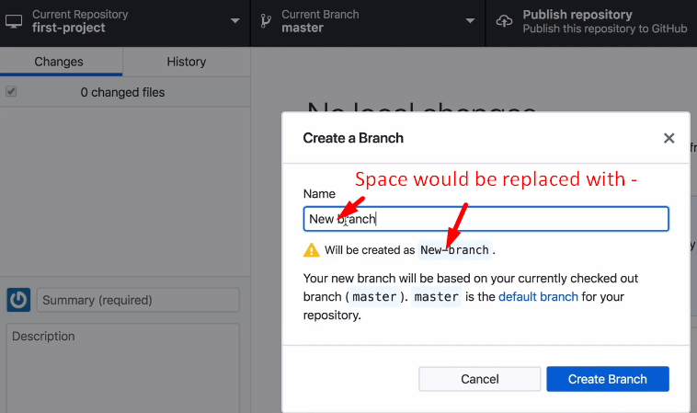
5. **Question**:  
   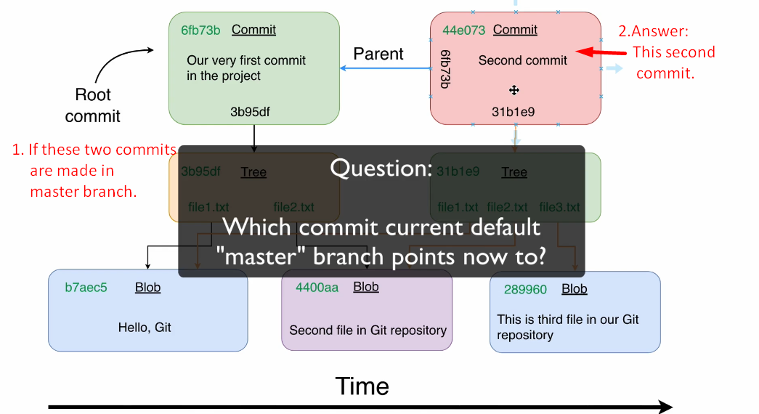
6. 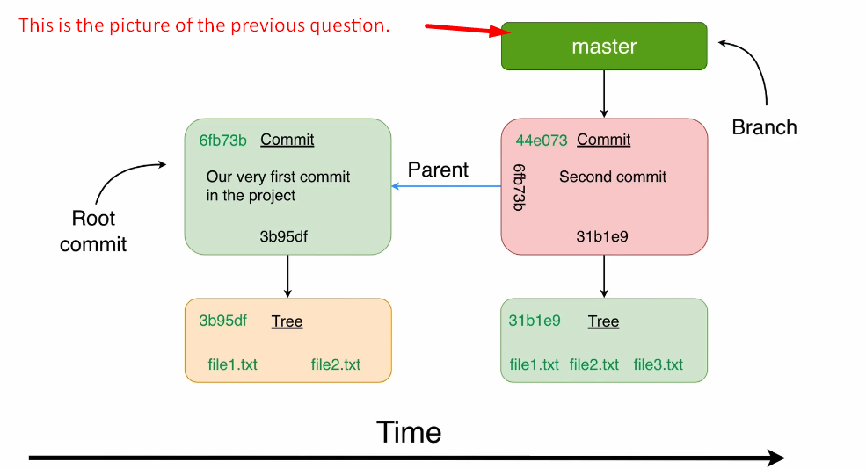
7. **NOTE**:
   1. Any branch is just a wrapper around the last commit in that branch.
   2. Let’s prove it.
8. **Proof**:
   1. 